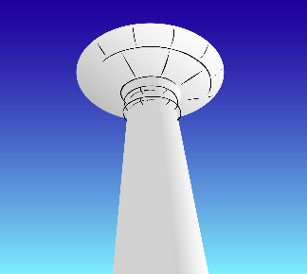
Montgomery Co. PWSD #1
PO Box 188
Warrenton, MO. 63383
636-456-8227

REQUEST FOR INSPECTION/COPY OF PUBLIC RECORD

Date of Request:__________________________
Record being requested: ____________________________________________________________
(Desribe the record as specifically as possible. If you are requestins records that cover only a particular period, such as last year or a specific month, please identify that time period)
Would you like a copy of the document? ______Yes _______No
How will documents be delivered to the requester? ____Email ____Mail ____Picked-Up
____Faxed (Fax Number)

Please print your information below:
Request By:
Name: _______________________________ Phone Number: ________________________
Address: ______________________________ City, St, Zip: _____________________________________
Email address: __________________________________________________________

Requesting party’s signature: __________________________________________________________

Please Note: Not all reports may be released. Some requests will involve extensive searches of records. State statute allows a rasonable length of time to allow the information to be gathered. A reasonable fee may also be charged for the time necessary to search for and copy public records and a deposit may be required.

To be completed by the District Clerk’s office:
Date request received:___________________________ Time Request Received:__________________

Received via: Mail_____ Phone_____ Walk-in____ Fax____ Other_________________

Amount of deposit required: ___________ Date requester contacted for deposit due: ____________

How was requester contacted for deposit? Phone Email Letter Fax

Date Requester contacted for pick up ___________ By: Phone Email Letter Fax

If request was denied, date and reason: ________________________________________________________

Record request completed by: _________________________
Start time ______________ End time______________ Total pages___________

Total time _______ @ _______ per minute
Fee for time_________________
Total pages____________
Other ____________________________________________

